SUBMITTED BY: SHEEZA SAJID

RED TEAMIING GROUP 2(FEMALE)
TASK 1: Network Security Fundamentals

SAFEX-TEAM INTERNSHIP
NETWORK SECURITY FUNDAMENTALS
Instructions:
1.Create a free account on TryHackMe (or similar) and complete an introductory network security room.
2. Take notes on key concepts covered (ports, protocols, common misconfigurations).
3. Summarize 3-5 key takeaways relevant to client engagements.
4. Only interact with the platform's own designated lab machines.

1.Objective
To learn the fundamentals of network security by completing a free TryHackMe lab and understanding common network ports, protocols, and basic security concepts.

Steps Performed
- I created a free account on the TryHackMe platform.
- After logging in, I searched for the Network Security Fundamentals room.
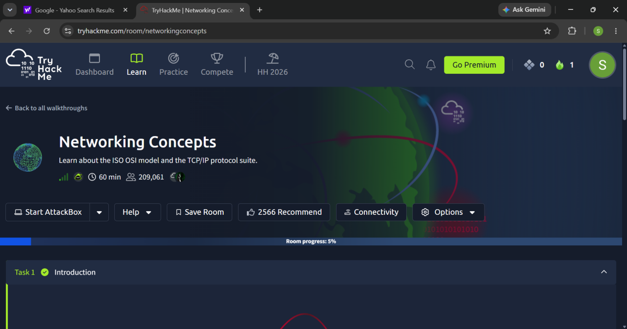
- I started the room and launched the provided virtual machine/AttackBox.
- I completed all the tasks and answered the required questions.
- During the lab, I learned about:
- Network Ports
- Common Protocols
- TCP and UDP
- OSI Model
- Encapsulation
- Telnet and HTTP
- Basic Network Services
After successfully completing the room, I received the completion confirmation.
I prepared notes covering ports, protocols, misconfigurations, and key networking concepts.

ROOM NAME: NETWORKING CONCEPTS

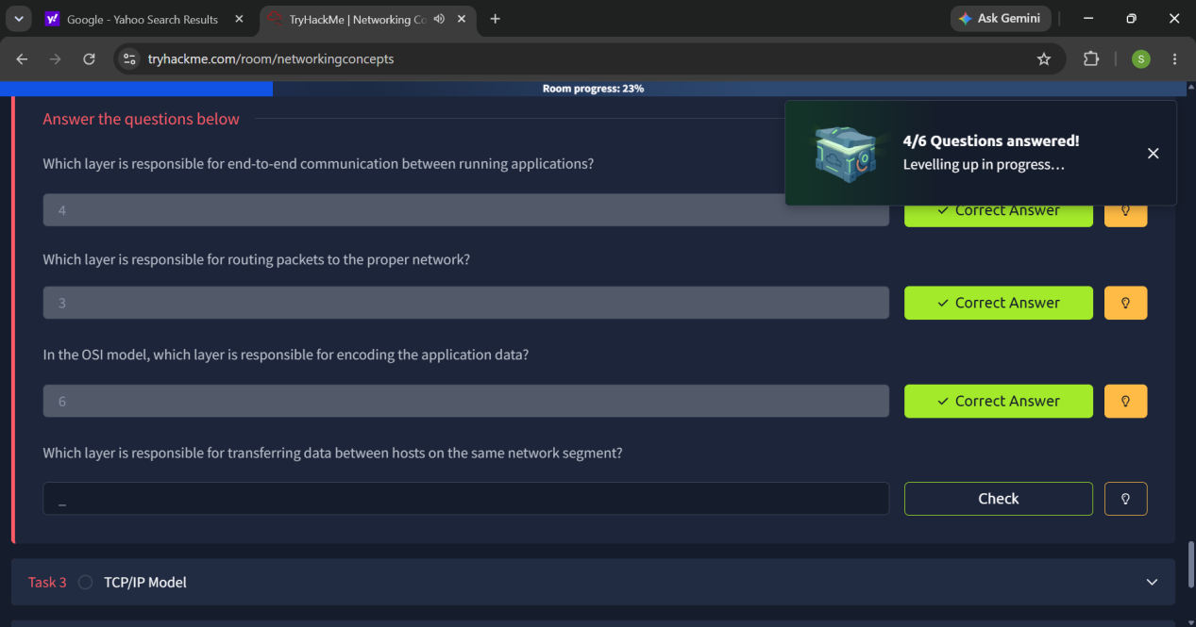

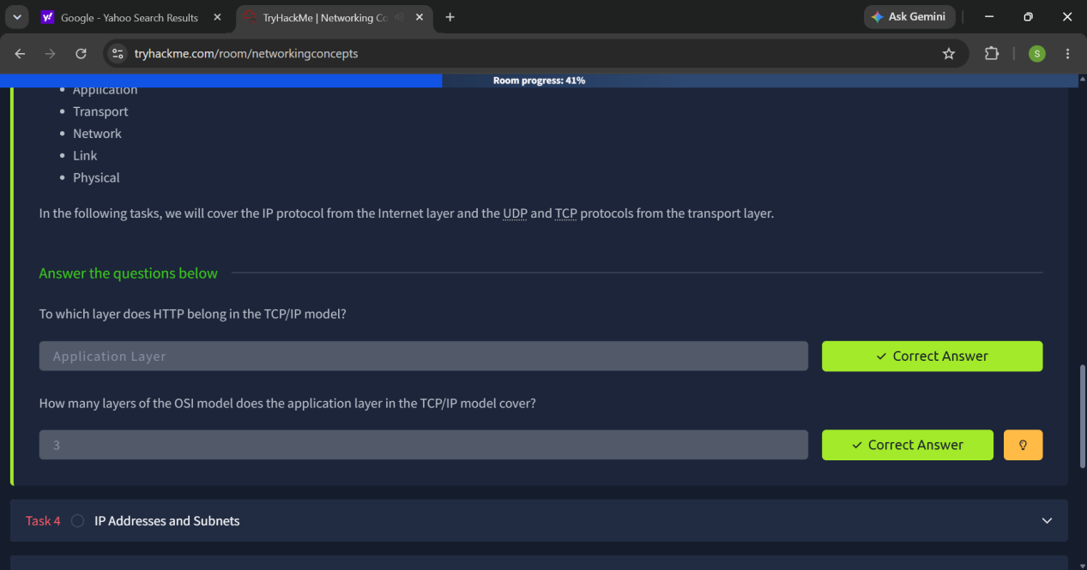

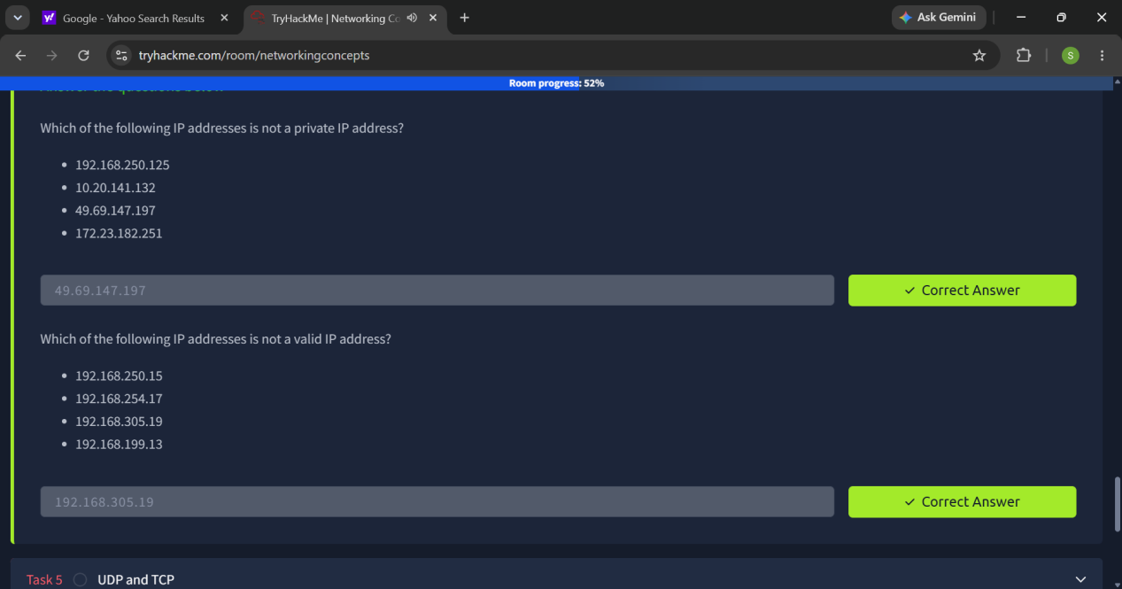

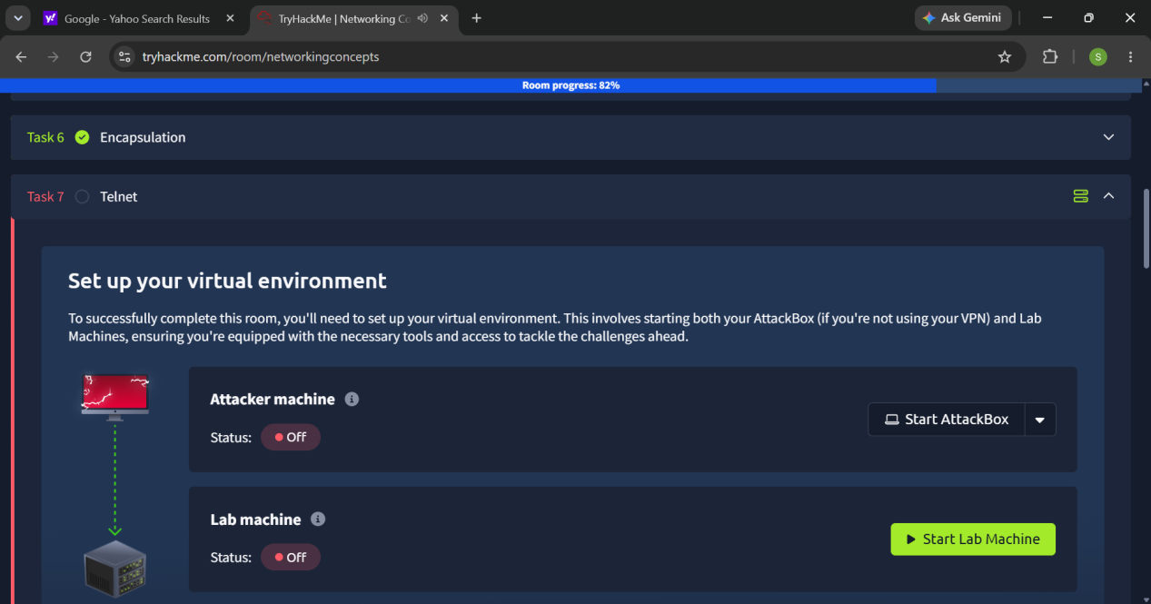

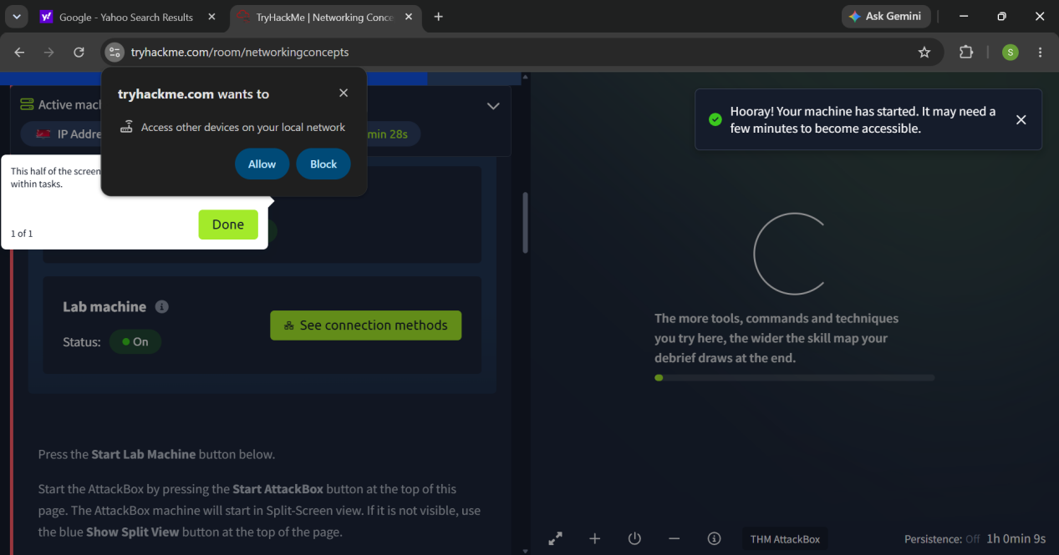

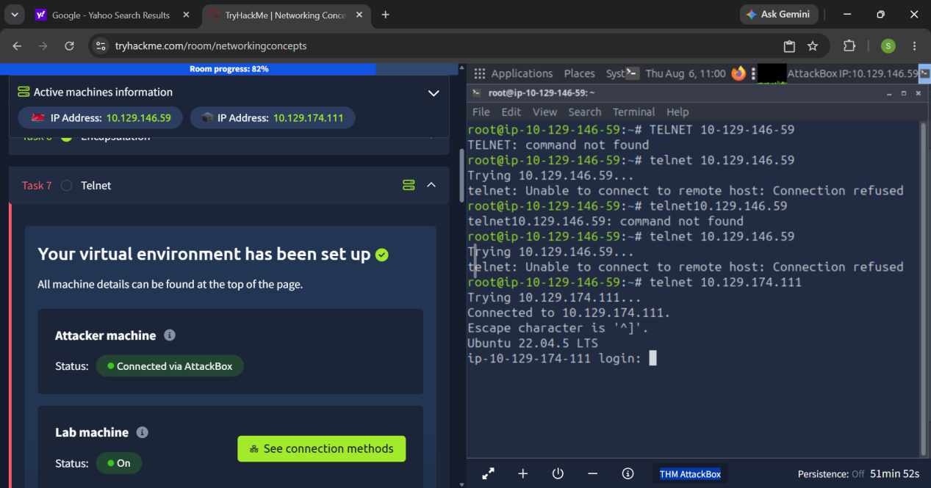

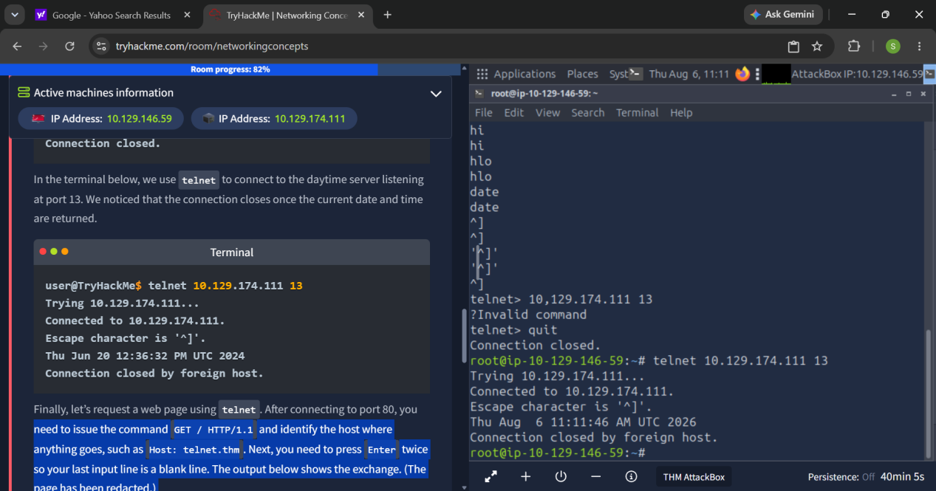

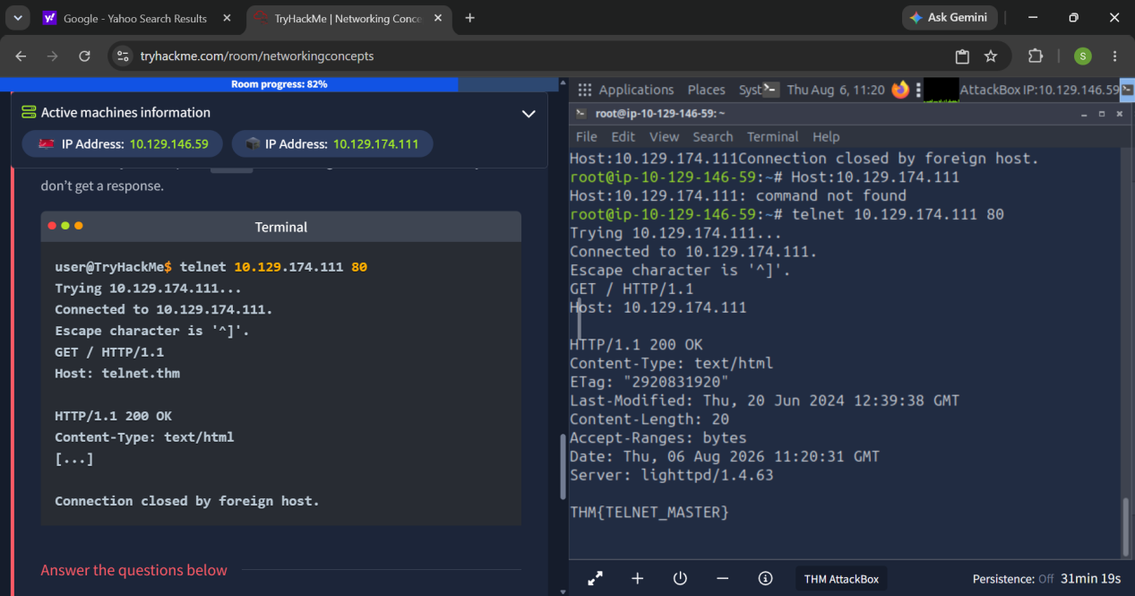

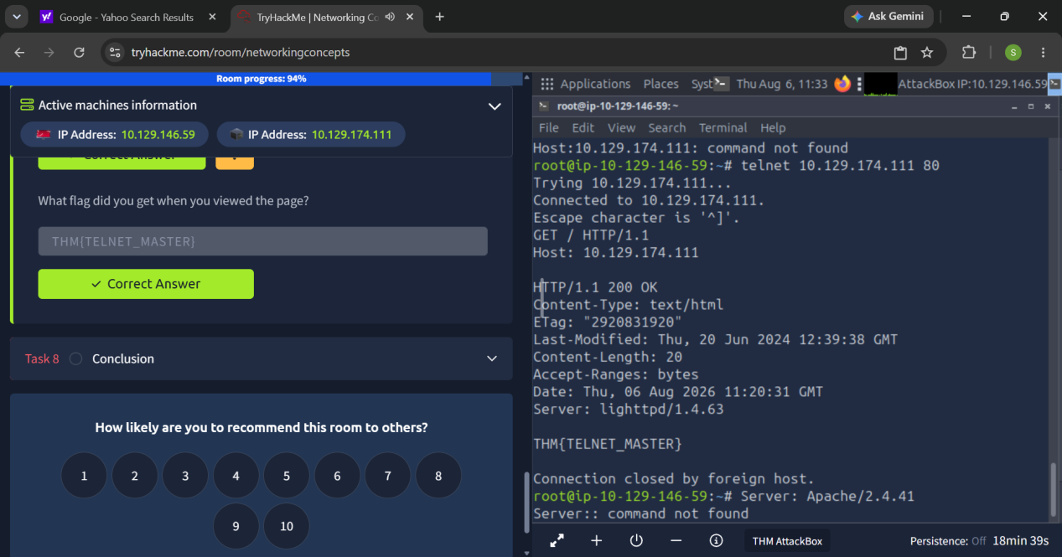

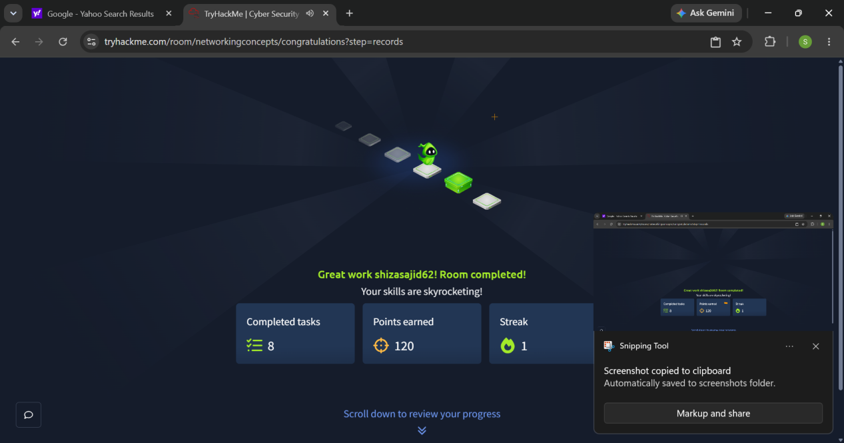

Notes

What is a Port?
Port
A port is a logical communication endpoint that allows data to reach the correct application or service on a computer.
Total Number of Ports:
- 65,536 ports
- Range: 0–65535

Types of Ports
1. Well-Known Ports (0–1023)
- Reserved for common network services.
2. Registered Ports (1024–49151)
- Used by applications and software.
3. Dynamic/Private Ports (49152–65535)
- Used for temporary client connections.

Common Port Numbers

PORT | PROTOCOL | PURPOSE
20 | FTP (Data) | Transfers file data between client and server.
21 | FTP (Control) | Establishes and manages FTP connections.
22 | SSH | Secure remote login and encrypted communication.
23 | Telnet | Remote login (not secure).
25 | SMTP | Sends emails between mail servers.
53 | DNS | Converts domain names into IP addresses.
67 | DHCP Server | Assigns IP addresses to devices.
68 | DHCP Client | Receives IP configuration from the DHCP server.
80 | HTTP | Used for web browsing.
110 | POP3 | Downloads emails from the mail server.
143 | IMAP | Accesses and manages emails on the mail server.
443 | HTTPS | Secure web browsing using SSL/TLS encryption.

2. What is a Protocol?
A protocol is a set of rules that defines how devices communicate over a network.

Common Network Protocols

HTTP
- Port 80
- Used for web browsing.
- Not encrypted.

HTTPS
- Port 443
- Secure version of HTTP.
- Uses encryption (SSL/TLS).

FTP
- Ports 20/21
- Used to transfer files.

SSH
- Port 22
- Secure remote login.
- Encrypted communication.

Telnet
- Port 23
- Remote login.
- Sends data in plain text (not secure).

DNS
- Port 53
- Converts domain names into IP addresses.

SMTP
- Port 25
- Sends emails.

POP3
- Port 110
- Downloads emails from a mail server.

IMAP
- Port 143
- Allows users to access and manage emails on the server.

DHCP
- Ports 67/68
- Automatically assigns IP addresses to devices.

3. TCP vs UDP

TCP (Transmission Control Protocol)
- Reliable
- Connection-oriented
- Error checking
- Slower but accurate
Examples:
- HTTP
- HTTPS
- FTP
- SSH

UDP (User Datagram Protocol)
- Faster
- Connectionless
- No error checking
Examples:
- Online Gaming
- Video Streaming
- VoIP Calls
- DNS

4. OSI Model (7 Layers)
- Physical Layer – Transmits bits/signals.
- Data Link Layer – Uses MAC addresses and frames.
- Network Layer – Uses IP addresses and routing.
- Transport Layer – Provides end-to-end communication using TCP/UDP.
- Session Layer – Establishes, manages, and terminates sessions.
- Presentation Layer – Handles encryption, compression, and data formatting.
- Application Layer – Provides network services to users (HTTP, FTP, SMTP).

5. Encapsulation
Encapsulation is the process of adding headers to data as it moves through the OSI layers before transmission.
Data Flow:
- Application Layer → Data
- Transport Layer → Segment
- Network Layer → Packet
- Data Link Layer → Frame
- Physical Layer → Bits
The reverse process at the receiver is called Decapsulation.

. Misconfigurations
A misconfiguration is an incorrect or insecure system configuration that creates security vulnerabilities.

Common Misconfigurations
- Default passwords
- Open or unused ports
- Weak passwords
- Missing software updates
- Incorrect file permissions
- Disabled firewall
- Publicly accessible sensitive files

Risks
- Unauthorized access
- Data theft
- Malware infection
- Server compromise

Prevention
- Use strong passwords.
- Close unused ports.
- Keep systems updated.
- Enable firewalls.
- Use HTTPS and SSH instead of HTTP and Telnet.
- Follow the Principle of Least Privilege.

- KEY TAKEWAYS:
- learned the basics of network security and understood how devices communicate over a network using ports and protocols.
- I learned the importance of common ports such as HTTP (80), HTTPS (443), SSH (22), FTP (21), DNS (53), and Telnet (23), and how each port is used for a specific service.
- I understood the difference between TCP and UDP. TCP provides reliable communication with error checking, while UDP is faster and is mainly used for real-time applications.
- I learned how network protocols work. I studied protocols such as HTTP, HTTPS, FTP, SSH, DNS, SMTP, POP3, IMAP, and DHCP, and understood their roles in network communication.
- I gained knowledge of the OSI Model and learned how data travels through the seven layers of a network.
- I learned about encapsulation and decapsulation, understanding how data is converted into segments, packets, frames, and bits before transmission and reconstructed at the destination.
- I practiced using Telnet to connect to remote services and understood how different ports respond to different network services.
- I learned that misconfigurations such as open ports, weak passwords, and default settings can create security vulnerabilities and should be avoided.
- I improved my practical cybersecurity skills by completing hands-on exercises in TryHackMe instead of only studying theory.
- This lab increased my confidence in using basic networking concepts and prepared me for more advanced cybersecurity topics.

